Korak 3 — FastAPI backend
Sada radimo backend koji:
- čita podatke iz CrateDB
- daje REST API
- daje WebSocket realtime stream
- šalje podatke Vue dashboardu
- podržava geo i alarm queryje
Koristit ćemo:
- FastAPI
- asyncpg
- Uvicorn
- WebSockets

Struktura backenda
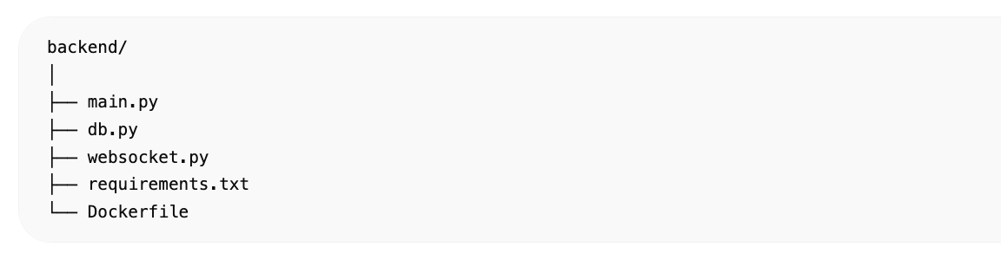

requirements.txt
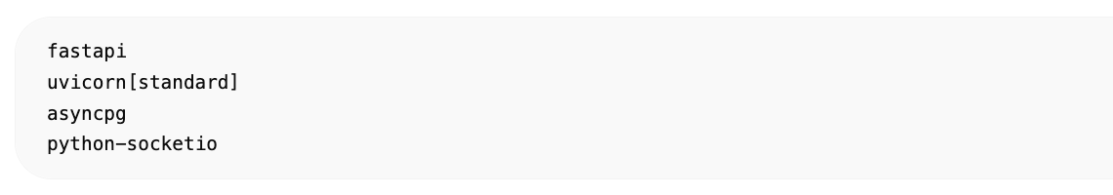fastapi
uvicorn[standard]
asyncpg
python-socketio

db.py
Konekcija prema CrateDB.
import asyncpg  DATABASE_URL = (  "postgresql://crate@cratedb:5432/doc"  )  pool = None  async def connect_db():  global pool  pool = await asyncpg.create_pool(  DATABASE_URL,  min_size=5,  max_size=20  )  async def get_latest_stations():  query = """  SELECT *  FROM trafostanice_sensors  ORDER BY timestamp DESC  LIMIT 1000  """  async with pool.acquire() as conn:  rows = await conn.fetch(query)  return [dict(r) for r in rows]  async def get_active_alarms():  query = """  SELECT *  FROM trafostanice_sensors  WHERE alarms['overheating'] = true  OR alarms['overload'] = true  ORDER BY timestamp DESC  LIMIT 100  """  async with pool.acquire() as conn:  rows = await conn.fetch(query)  return [dict(r) for r in rows] | 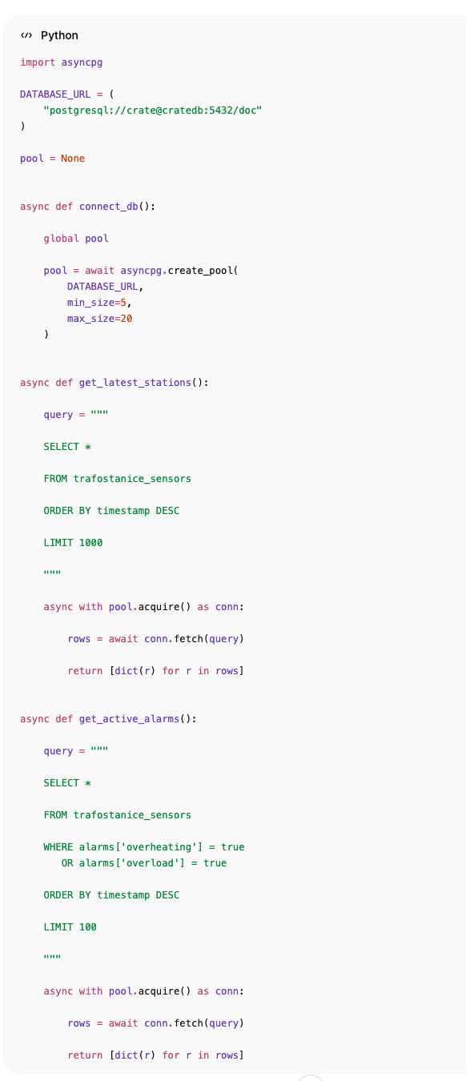

websocket.py
Realtime WebSocket stream.
import asyncio  from socketio import AsyncServer  from db import get_latest_stations  sio = AsyncServer(  async_mode="asgi",  cors_allowed_origins="*"  )  async def sensor_stream():  while True:  data = await get_latest_stations()  await sio.emit(  "sensor_update",  data  )  await asyncio.sleep(1) | 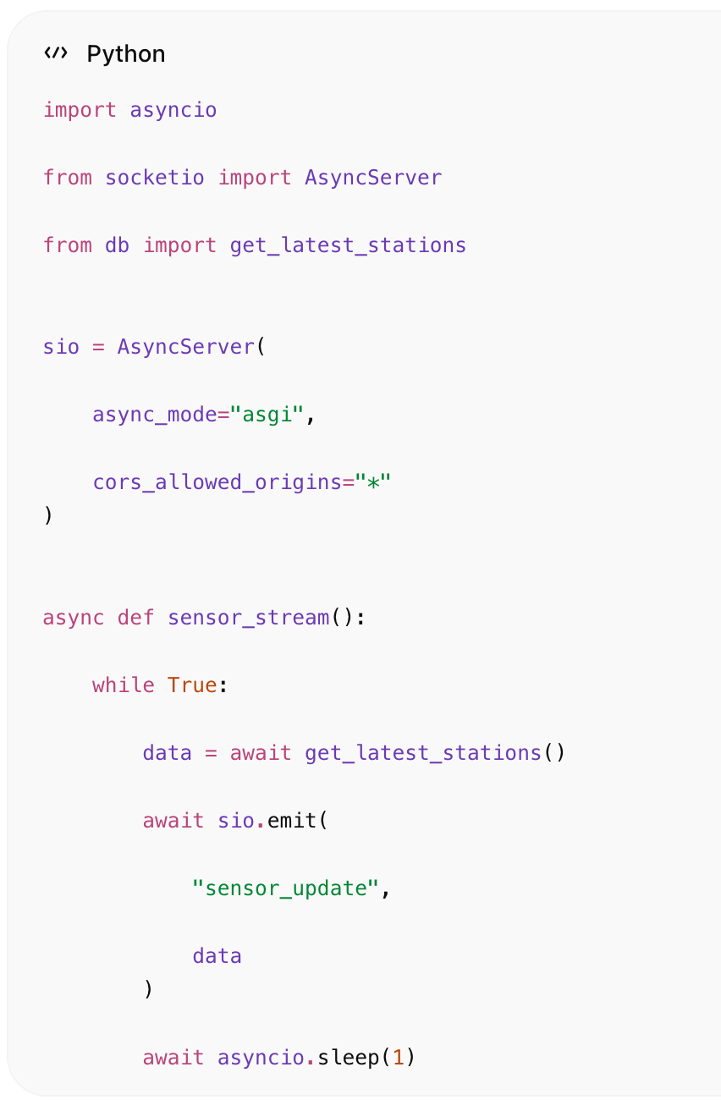

main.py
Glavni backend.
import asyncio  from fastapi import FastAPI  from fastapi.middleware.cors import CORSMiddleware  from socketio import ASGIApp  from db import (  connect_db,  get_latest_stations,  get_active_alarms  )  from websocket import (  sio,  sensor_stream  )  app = FastAPI()  app.add_middleware(  CORSMiddleware,  allow_origins=["*"],  allow_credentials=True,  allow_methods=["*"],  allow_headers=["*"]  )  @app.on_event("startup")  async def startup():  await connect_db()  asyncio.create_task(  sensor_stream()  )  @app.get("/stations")  async def stations():  return await get_latest_stations()  @app.get("/alarms")  async def alarms():  return await get_active_alarms()  @app.get("/")  async def root():  return {  "status": "running"  }  socket_app = ASGIApp(  sio,  other_asgi_app=app  ) | 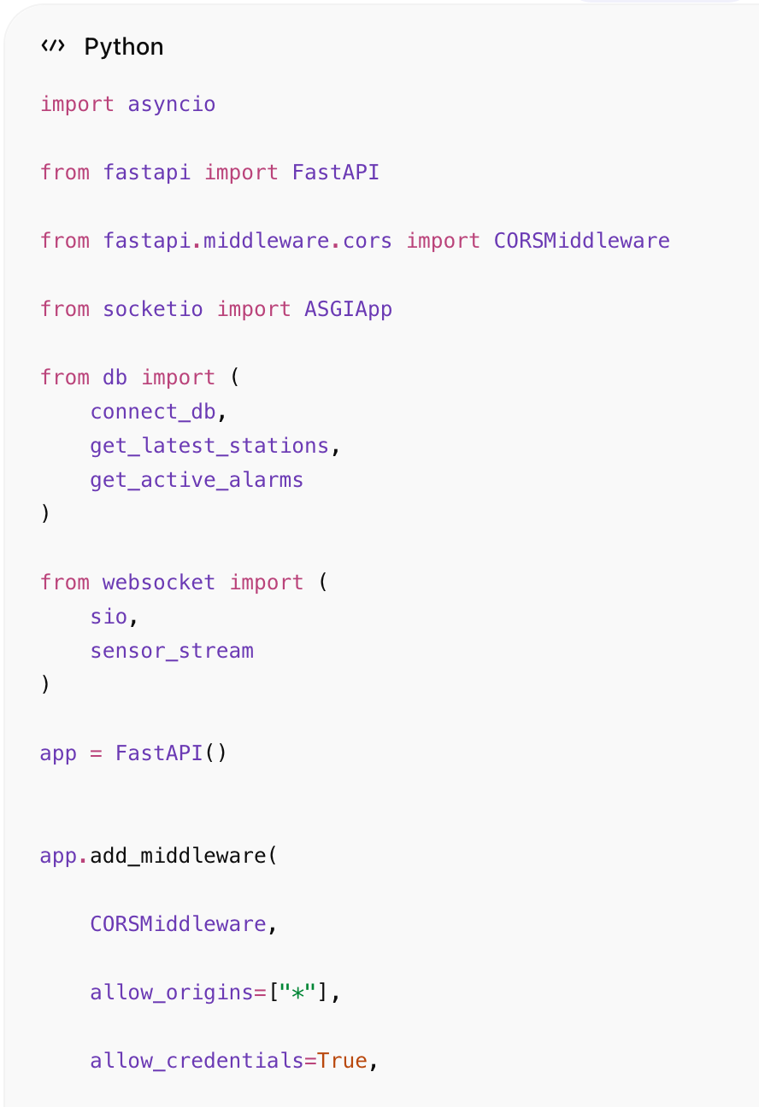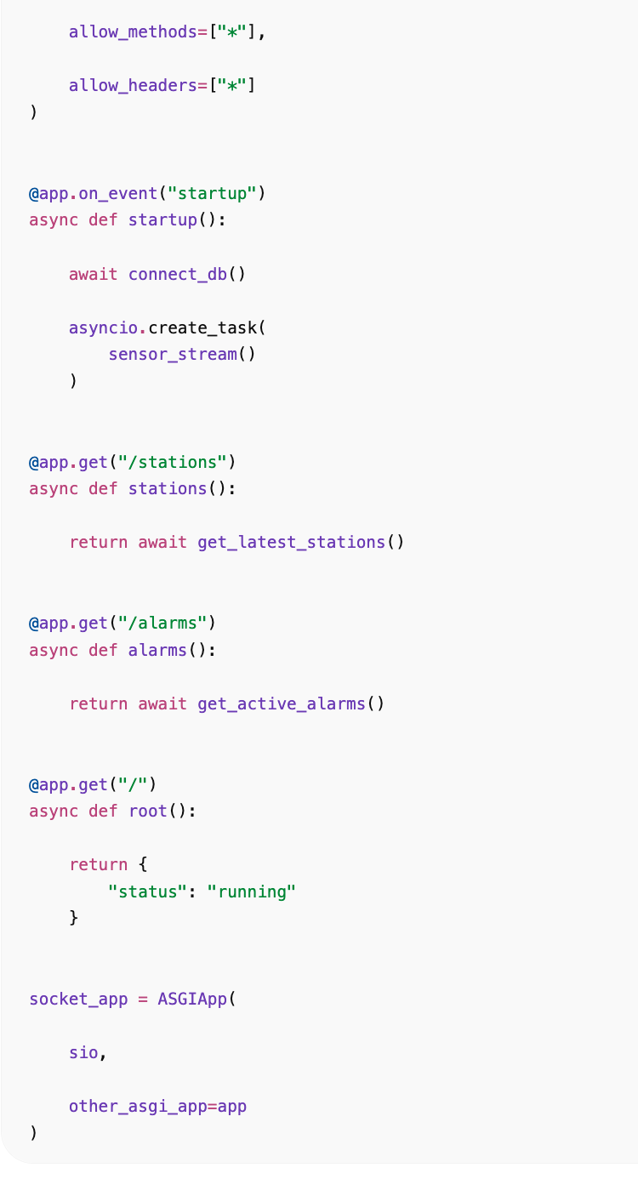

Dockerfile
FROM python:3.11  WORKDIR /app  COPY requirements.txt .  RUN pip install -r requirements.txt  COPY . .  CMD [  "uvicorn",  "main:socket_app",  "--host",  "0.0.0.0",  "--port",  "8000"  ] | 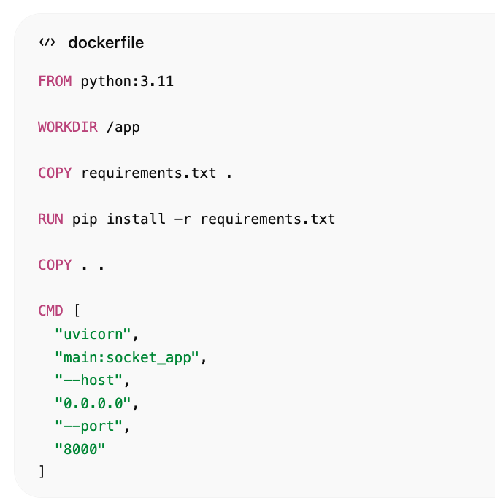

Docker compose update
Dodaj backend:
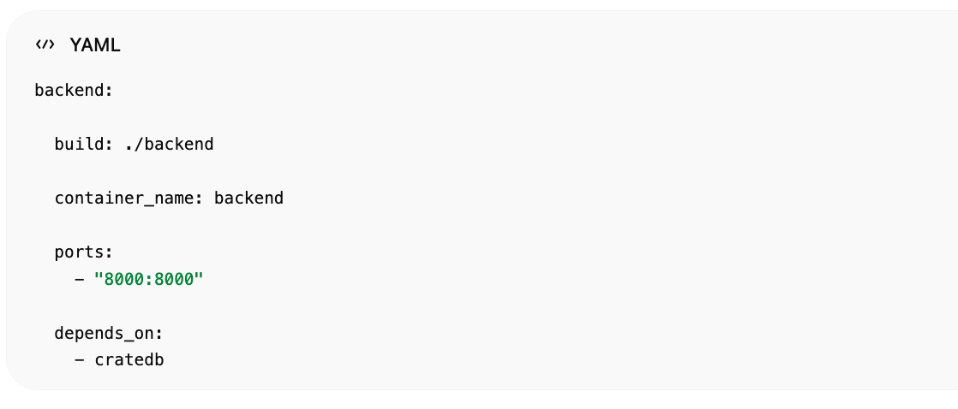
backend:
build: ./backend
container_name: backend
ports:
- "8000:8000"
depends_on:
- cratedb

Pokretanje
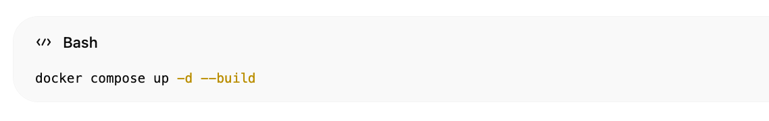docker compose up -d --build

Test API

Backend status
http://localhost:8000

Sve trafostanice
http://localhost:8000/stations

Aktivni alarmi
http://localhost:8000/alarms

WebSocket
Socket.IO endpoint:
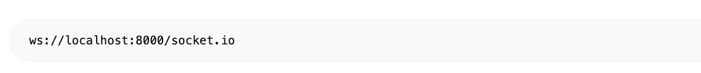ws://localhost:8000/socket.io

Što backend sada radi

REST API

GET /stations
Vraća:
- zadnje podatke
- geo lokacije
- senzore
- alarme

GET /alarms
Vraća:
- overload
- overheating

WebSocket
Realtime:
- live update svake sekunde
- streaming prema Vue dashboardu

Primjer JSON odgovora
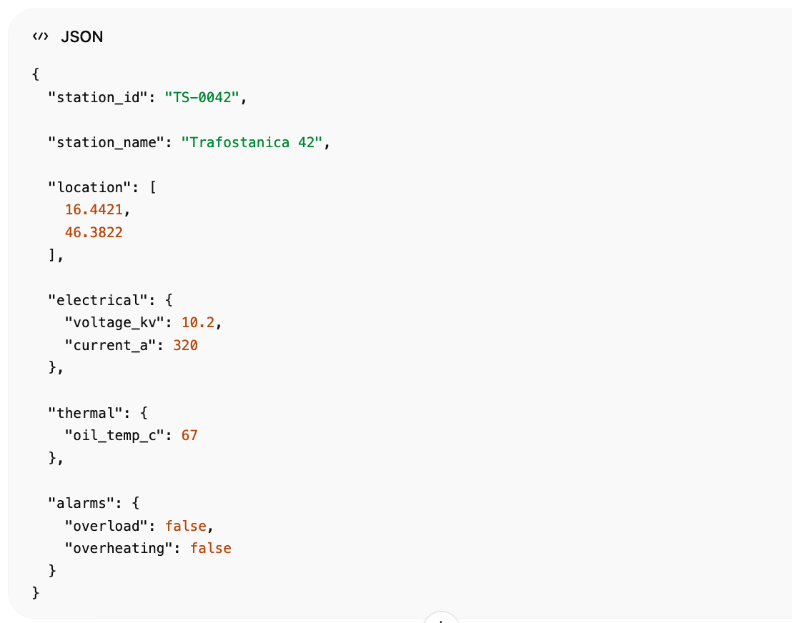

Performance
Ovaj backend može:
- realtime streamati 1000 trafostanica
- držati websocket konekcije
- raditi geo queryje
- alarm monitoring
- SCADA dashboard support

